Save A Life For Scotland

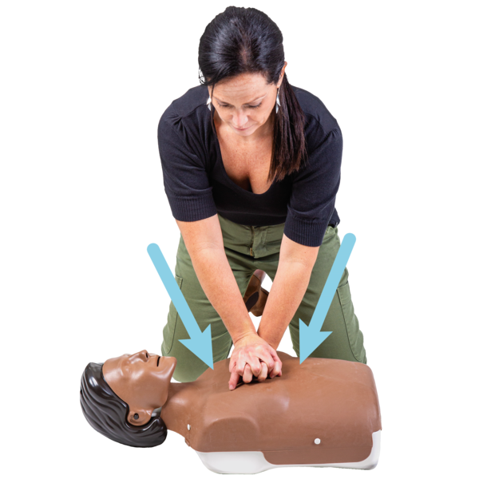
How to help someone in cardiac arrest

Easy Read

Copyright images © Photosymbols / Canva Prepared by Disability Equality Scotland

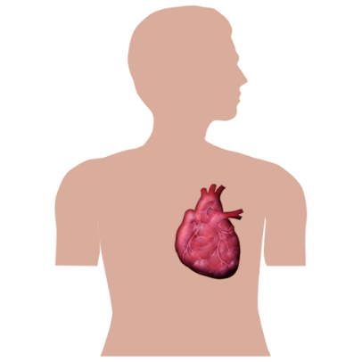 | How to tell if someone is in cardiac arrest  Cardiac arrest means that someone’s heart has stopped working properly.
A person is in cardiac arrest if:
- they are not answering back to you or moving
- they are not breathing normally
They might be making gasping noises instead of breathing normally.

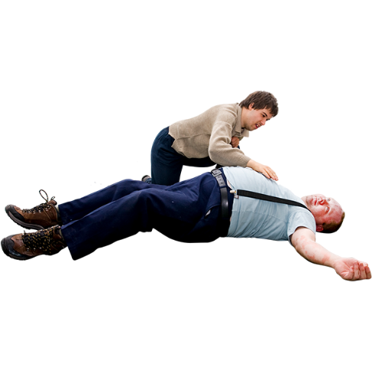 | You can shake them gently to see if they are conscious.  You can look at their chest moving up and down to see if they are breathing.
If the answer is no to both these checks, then they are in cardiac arrest.
They need help straight away.
Call for help

Make sure you feel safe.
Shout out to ask for help from anyone nearby.
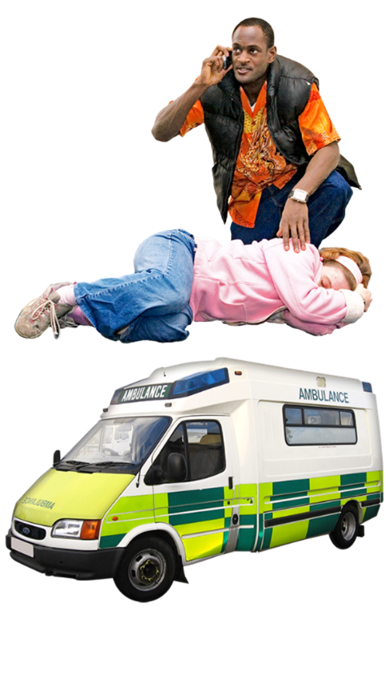 | Call 999 on a phone and ask for an ambulance.  The person you talk to on the phone will help you.  They will tell you what to do next.
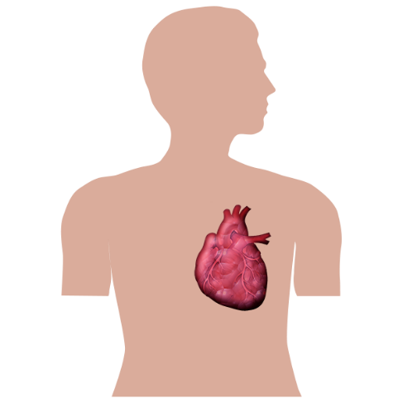 | Doing CPR with just your hands  CPR means cardiopulmonary resuscitation – a way of getting the heart to work again.
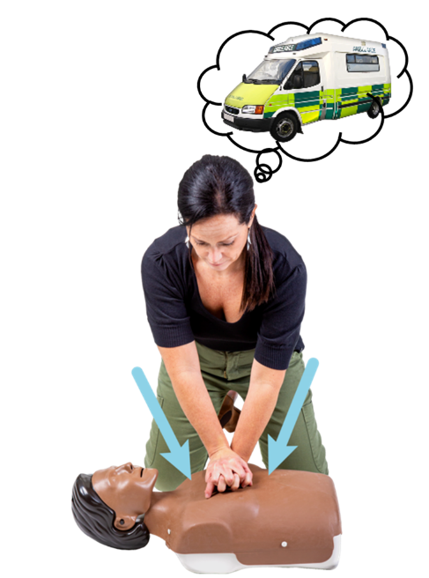 | Start doing CPR straight away and carry on until the ambulance gets there.
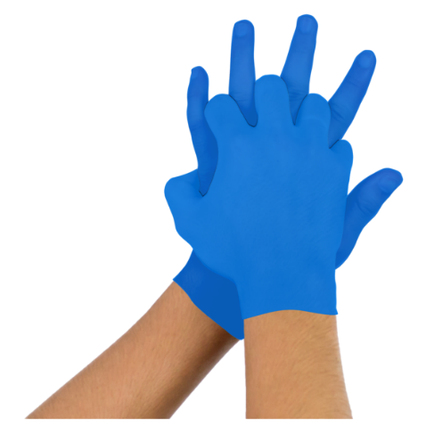 | 1. Put the heel of your hand on the middle of the person’s chest.  Put your other hand on top and link your fingers together.
 | 2. Lean over so that your shoulders are above your hands.
3. Use the weight of your whole body and keep your arms straight as you press down on their chest.
Their chest should go down about 5 centimetres.
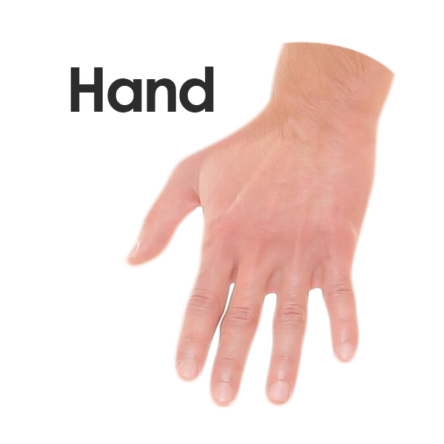 | 4. Let go so their chest rises back up.
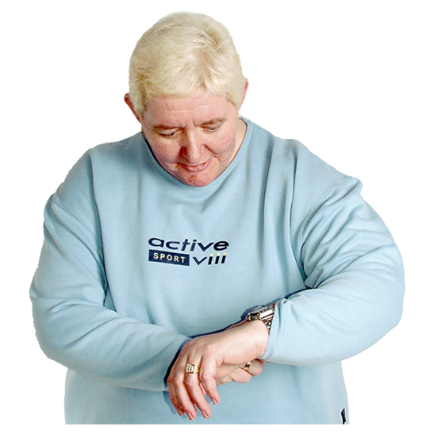 | 5. Keep doing these pushes down. You need to do about 2 pushes each second.
 | If you know the song called Stayin’ Alive by the Bee Gees, the chest pushes should be the same speed as the beat to this song.
6. Keep going for as long as you can.
Other people can take a turn if you get tired.
Try and keep going until the ambulance gets there.

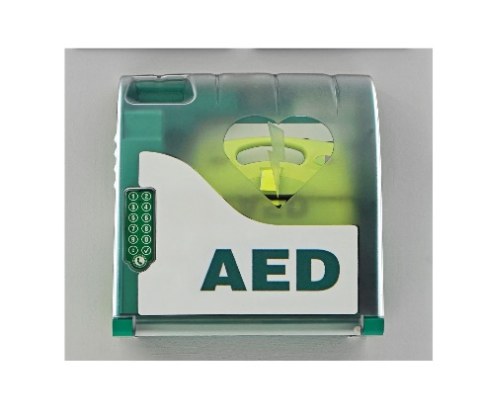 | Defibrillator Machines  A defibrillator is a machine that can give an electric shock to help start someone’s heart again.
Defibrillators are often kept on the walls in public areas like:
- town squares
- libraries
If you can, send someone to find a defibrillator.
The 999 phone person will tell you if there is one nearby.
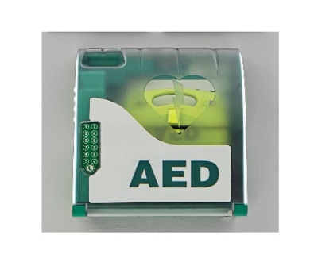  This is what to do… | Anyone can use a defibrillator.  It uses a speaker to give instructions.  If needed, it will give an electric shock by itself.
How to use a defibrillator

1. Turn the defibrillator on.
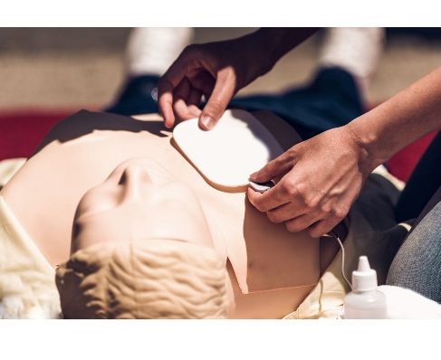 | 2. Peel off the sticky pads. Stick them to the person’s skin – the picture will show you where.
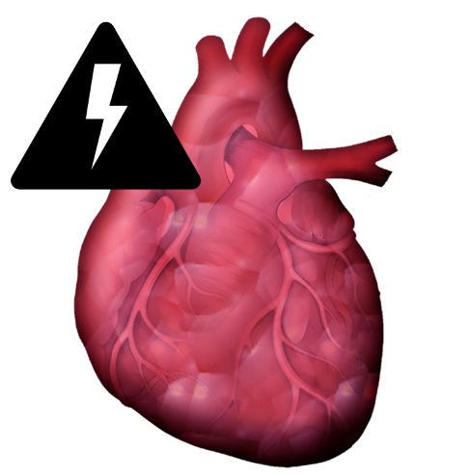 | 3. The defibrillator will check the person’s heart beat and it will decide if an electric shock is needed.
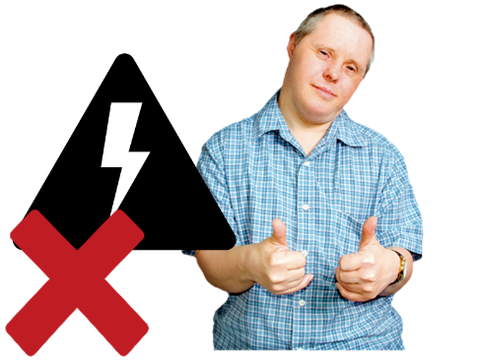 | Don’t worry – you can’t give someone a shock accidentally.
 | If the person needs an electric shock, the defibrillator will tell you to press the shock button.
 | Don’t touch the person while they are being shocked.
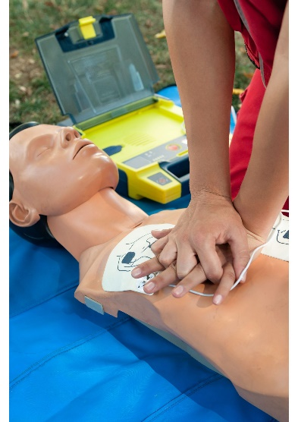 | 4. Keep listening to the instructions from the defibrillator.  It might tell you to keep going with CPR until the ambulance arrives.
 | This is the end of the Easy Read document.

