How to send a text to get help in an emergency

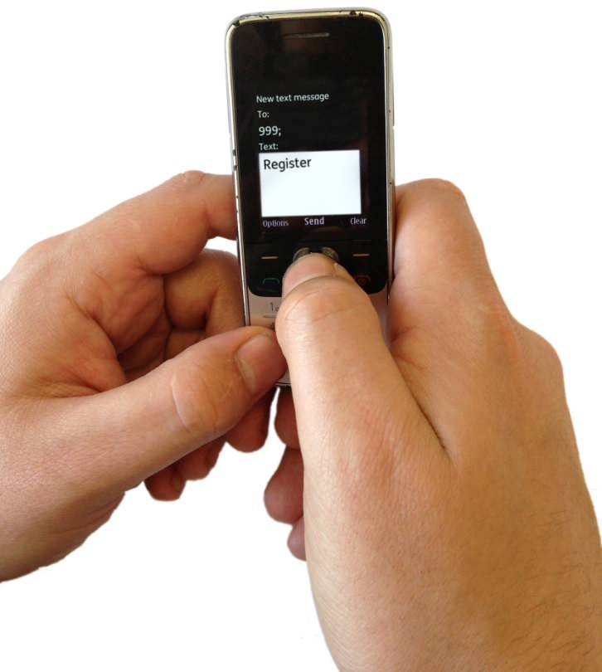
An emergency is when you need help from people like the ambulance service straight away.

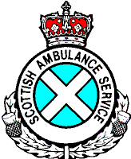 About this leaflet
Easy read

This leaflet says how to get help in an emergency if you find it hard to hear or speak.

An emergency could be times like when

- someone might die

- a crime is happening

- there is a fire

- someone is in trouble in the sea. Or near the sea.

In times like these here are the people who could help you

- the police can help with crimes

- the ambulance service can help if someone is hurt or ill

- the fire service can help with fires. Or if someone is stuck somewhere and can’t get out

- the coastguard can help if someone is in trouble in the sea. Or near the sea.

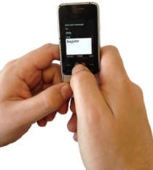
If you find it hard to hear or speak you can send a text message to 999 to get help from these people.

This leaflet tells you how to send this text so you can get help in an emergency.

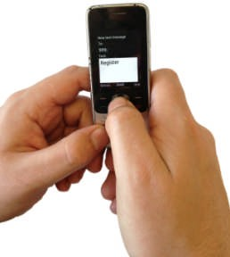
How to get your phone ready so you can text for help later on

You need to set your phone up before you can send a text to 999

Don’t wait for an emergency to happen before you do this.

It is a good idea to do this now. Then you know you can text 999 in an emergency.

The next page says what to do to get your phone ready.

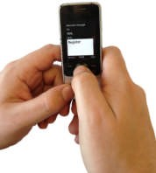

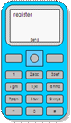
What you need to do

- Type the word register in your phone.

Send it in a text message to 999. Don’t type anything else.

- You will get a text back with more information.

The message will say this – “After reading all this message send the word ‘ Yes’ to 999 to complete your registration. Otherwise your phone is not registered. In an emergency you will know your message has been received only when you get a reply from an emergency service”.

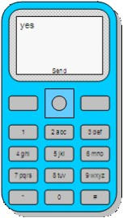
- Reply to this text. Type yes.

Don’t type anything else in this text.

- If you get a text back then this has gone ok.

If you do not get a text back then there has been a problem.

Get in touch with us to sort the problem out. To do this you can

  - go on our website. Our website address is www.emergencysms.org.uk

  - send an email to text.relay.helpline@bt.com

  - tell someone who could help you.

If an emergency happens this is what you should do

Send a text message to 999.

Try to tell us these things in your text

Who you want help from

You might want help from the

  - police

  - fire service

  - ambulance

  - coastguard.

What the problem is
For example if someone is hurt.

Where you are

This could be somethi ng like outside the swimming pool. Or the name of the road you are on.

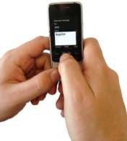
If you are not sure about these things you can still text us and we will try to help you.

You might have to wait for about 3 minutes before we text you back.

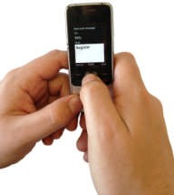
If we don’t get back to you in 3 minutes then

- send the text again

- try to find another way of getting help. For example you could ask
  - someone near you
  - a friend
  - someone in your family.
Easy words by Mencap. Most pictures by Photosymbols 8

