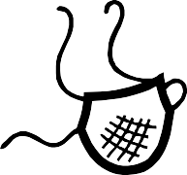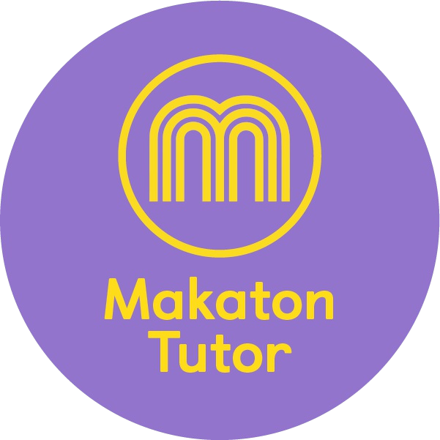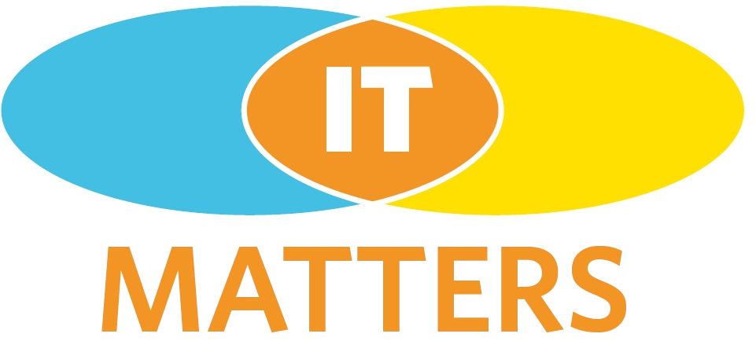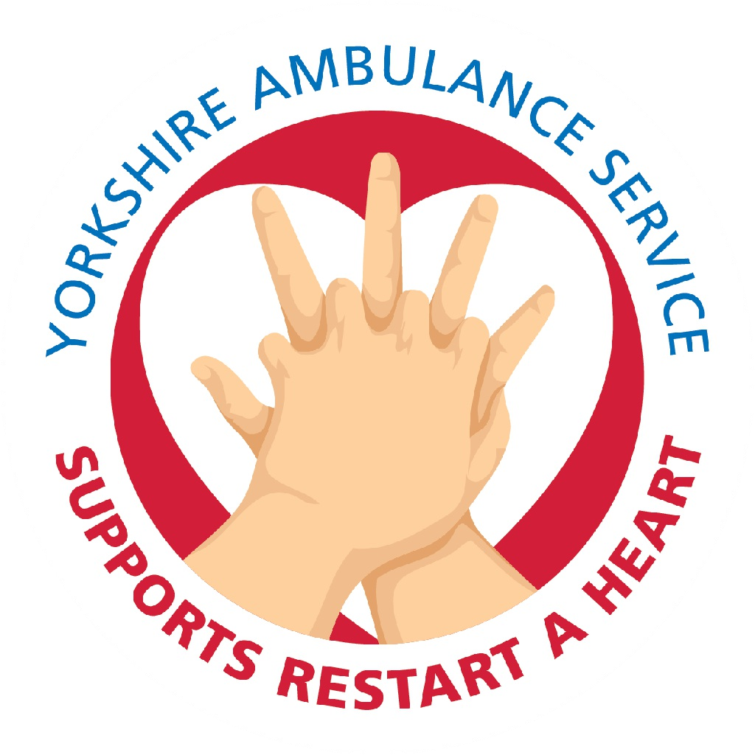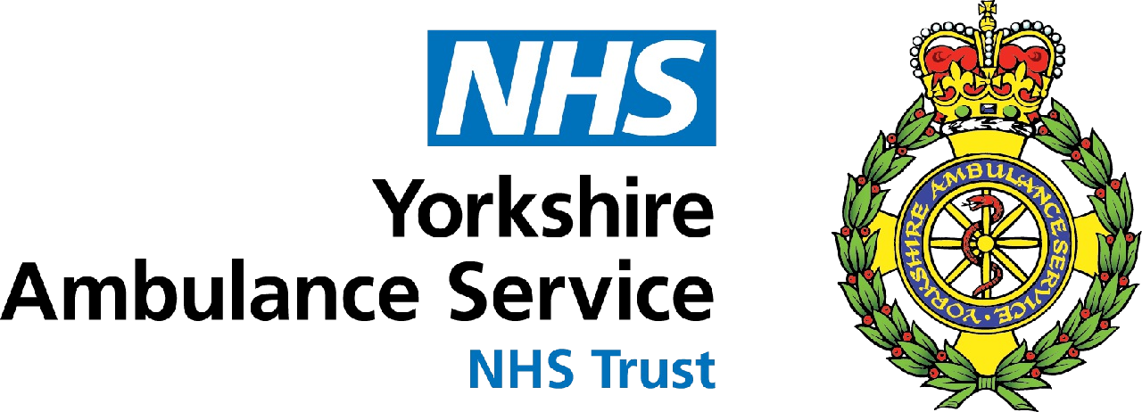

Mask

Calm

Hear

Prompt Cards - Restart a Heart
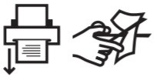
Best printed as 2-sided, actual size. Laminate and cut up to attach to a key ring for quick reference prompt. Resource created by Makaton Ambassador Tutors Amanda Glennon and Kerry Cawley

Hello

Heart

Danger

Help

Look

Shout

Telephone

Okay

Ambulance

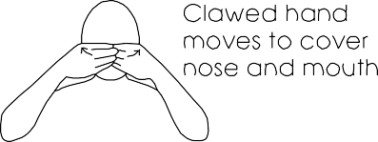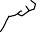

Mask

Hear

Calm

Prompt Cards - Restart a Heart
Best printed as 2-sided, actual size. Laminate and cut up to attach to a key ring for quick reference prompt. Resource created by Makaton Ambassador Tutors Amanda Glennon and Kerry Cawley
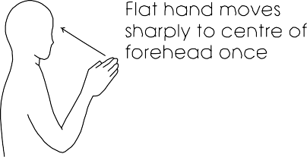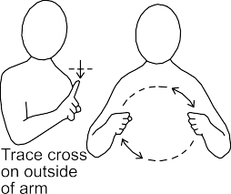

Danger

Heart

Hello

Shout

Look

Help

Ambulance

Okay

Telephone

